CHECKLIST FOR MANAGING IN TIMES OF FINANCIAL DIFFICULTY

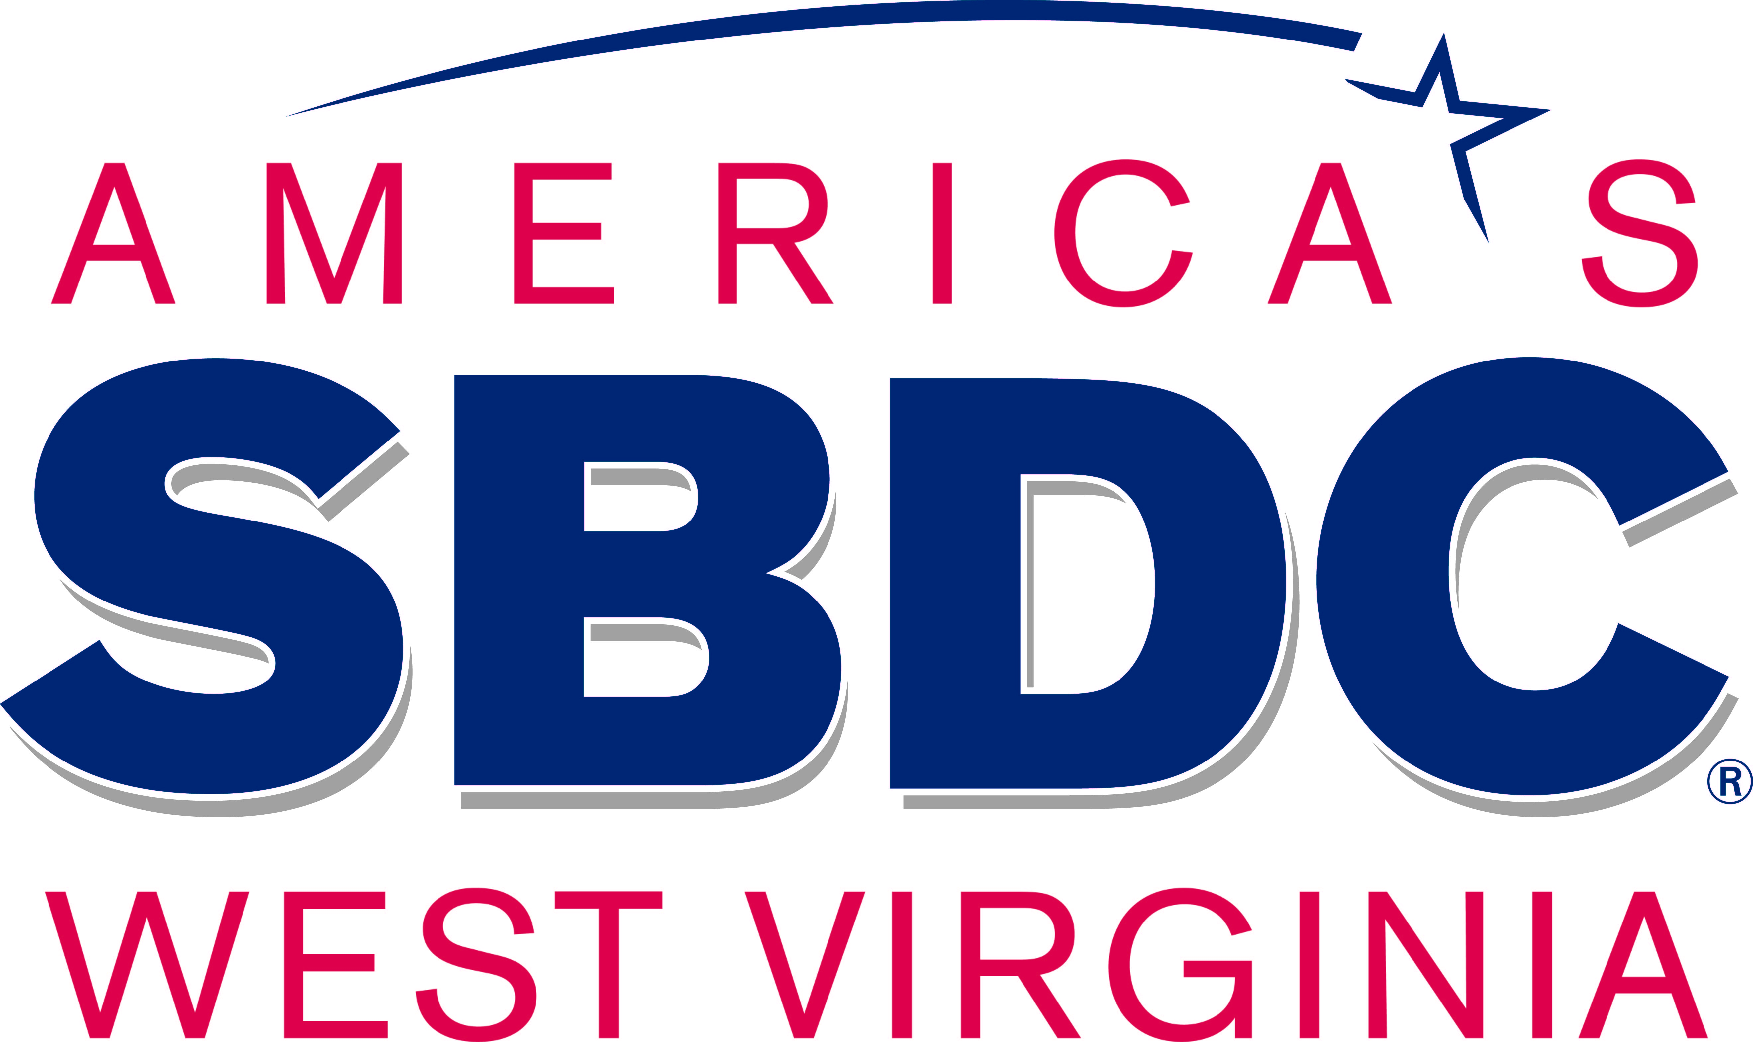

Checklist for managing in times of financial difficulty
This checklist is designed to give guidance to businesses on how they can manage through difficult times. Difficulties can be caused by external factors such as a natural, economic or man-made disaster, a decrease in consumer confidence, rising fuel prices, increased competition, difficulty accessing finances and/or increasing interest rates; or they could be caused by internal factors such as poor risk management, failure to manage cash flow properly or because of low profit margins.

Regardless of the causes, small businesses need to act when the going gets tough. While there is no single cure-all, there are many steps a business owner can take to manage through the difficult times and position the business for future growth.

This checklist provides some tips and suggestions.

Taking stock of your business

Adopting a risk management mindset is the key. The first step is to take stock. Business owners need to identify and manage any weaknesses in their business or their industry’s performance, while not being blinded to any new opportunities that might emerge.

To take stock of your business, you should:

Understand your customers

Any business begins and ends with the requirements and behaviors of the customer. If your customers aren’t satisfied, the rest does not matter. It is therefore fundamental to understand your customers, including their paying habits. You need to understand why your customers buy your product or service. Is it a luxury or is it a discretionary product? Do you deal in mature products or staple items? Are your customers fickle and price sensitive or are they long-standing and faithful?

Measure, measure, measure

There are several key indicators which will quickly tell you how your business is tracking. They could be as simple as the value of daily sales, or your cash balance or your receivable’s balance, or the value of orders and invoices you owe to suppliers. Or they could be an activity indicator such as total billable hours, an occupancy or usage factor, the value of sales booked for next week or an average sales value. Create a graph showing these indicators and update it daily or at least weekly. It will quickly show an adverse in trends as they emerge.

WVSBDC.com

Act with a purpose and for the right reasons

Develop strategies that aim to boost your cash position and/or profitability (you can be making a profit but still go out of business because you lack enough cash), without starving the business of the essential investment in inventory or marketing. Keep looking for underlying improvements in the business; don’t just cut costs. In this way, your corrective actions will also put your firm on a better footing for longer-term success.

Change your attitude

Don’t just do what you’ve always done. Remember, that what you did last week may well have contributed to the unsatisfactory situation you find yourself in today. Consider new angles on old problems. Work on the parts of the business you can influence. Learn from others in the industry and be prepared to be flexible. Prepare financial statements and benchmark the information that emerges from them against industry averages. Get someone else to have a look at your business, either your CPA or a trusted business consultant.

Review your current position. Identify your problem areas and your strengths before trying to trade your way out of difficulty.

The importance of financial management cannot be overemphasized, especially when business conditions become difficult.

Ideas to improve the cash position of your business

While profits may be the measure of success, it is cash that determines business survival. It is very important for the viability of your business to convert your customers’ outstanding debt into cash.

- Prepare regular cash flow forecasts. If your business is having cash flow difficulties, you should be preparing such forecasts on a regular basis. They will show the likely extent of any crisis, and how long it might last.

- Keep an eye on your entire cash cycle. If you are in a difficult cash position, skew promotions towards those services or products which consume less resources or which can be turned into cash more quickly. In other words, generate cash through sales but don’t undersell your products or services. You must make a profit.

- Measure and reward the right behavior in your staff. For example, sales commissions should only be paid on receipt of payment, not necessarily when a sale is made. This will encourage sales staff to focus on making sales to customers who are most likely to pay.

- Make full use of your terms of credit as this amounts to an interest-free loan. Don’t pay your suppliers too early or outside of your agreed credit terms. Be a solid, dependable customer. Having a good reputation will give you better scope for negotiating deals and favorable credit terms.
- Don’t let personal draws get out of hand. Ideally, the owners should take a modest but regular wage and leave the remaining cash in the business. Keep fringe benefits or withdrawals of stock to a minimum.

- Don’t hide your problems from the bank. Keep the line of communication open. Demonstrate that you are on top of your business and understand your cash flow. Show you can provide financial information if you need to ask for temporary relief on loans.

To improve the cash position of your business
Prepare regular cash flow forecasts (see 13-week cash flow tool)
Generate cash through sales but do not undersell your products or services
Only pay sales commission when payment is received
Negotiate extended terms of credit with suppliers
Take modest personal draws and wages
Don’t hide problems from the bank. Tell your bank early if you need money to overcome a cash flow problem.

Ideas to improve the profitability of your business

A profitable business is generally a successful business and your margin is a measure of that success.

- Prepare financial statements on a regular basis. These will give you information you need to determine your overall profit margin and where costs can be saved. They can also be used to determine the margin on individual products and to compare how your business is performing against industry averages.

- Focus on boosting profit. Retained profits is an important source of cash to meet your obligations and it can also be used for investments. To maximize profit, you need to focus on sales that give you the highest margin, not just “sales”. The only exception to this rule is when you deliberately set out to achieve another aim such as liquidating inventory to make room for profitable products.

- If possible, don’t discount prices on lower margin products or services. Use an alternative strategy, such as bundling in support services for a higher price. This is an especially valuable strategy with slow moving lines as it justifies the investment in them.

- Understand the profit contributions of each of your products, and your main customers. This will show you where to best focus your efforts and identify opportunities for improvement.

- Don’t discount unless you can achieve the same or better gross profit margin. It may require large increases in sales to generate the same amount in gross profit. While some price discounting may be required to get shoppers’ attention, a much better approach is to deliver the discount through, for example, an add-on product. This should deliver more dollars of gross profit to the business. See the effect of discounting on gross profit below.

To improve the profitability of your business
Prepare financial statements on a regular basis and use them to analyze performance and benchmark your business against industry averages
Understand the profit you generate on each item of product or service you sell
Concentrate on improving sales of your most profitable products and services
Don’t discount prices on lower margin products and services
Don’t discount on your most profitable products or services unless the discount encourages increased sales that lead to at least the same profit

WVSBDC.com

The effect of discounting

Present Gross Profit Margin | 10% | 15% | 20% | 25% | 30% | 35% | 40%
If you cut your price by: | to achieve the same gross profit margin, you will need to increase sales by:
5% | 100% | 50.0% | 33.3% | 25.0% | 20.0% | 16.7% | 14.3%
6% | 150% | 66.7% | 42.9% | 31.6% | 25.0% | 20.7% | 17.6%
8% | 400% | 114.3% | 66.7% | 47.1% | 36.0% | 29.6% | 25.0%
10% |  | 200.0% | 100.0% | 66.7% | 50.0% | 40.0% | 33.3%
12% |  | 400.0% | 150.0% | 92.3% | 66.0% | 52.2% | 42.9%
15% |  |  | 300.0% | 150.0% | 100.0% | 75.0% | 60.0%
20% |  |  |  | 400.0% | 200.0% | 133.3% | 100.0%

Other ways of improving the cash position and profitability of your business: Control Costs

Costs need to be controlled to a level consistent with your business’ needs. Don’t just cut costs. Longer-term and recurring savings are better than short-term wins. Once the easy savings are made, focus on improving sales and gross profit, as that will have a larger impact on the future success of your firm.

- Identify the expenses that keep you in business. For example, building maintenance costs, advertising, staff training skills. Keep them at sustainable levels. Remember the old saying, “Penny wise, pound foolish.”

- Look at costs carefully, but don’t criticize every individual transaction. Often a review of the business’s processes can eliminate the need for certain costs completely. For example, total interest costs might be reduced by changing credit cards, by negotiating a lower rate with your bank or by reducing the amount of debt being used.

- Measure the success of each promotional activity or campaign. For example, direct mail advertising is considered more cost effective than advertisements in papers, magazines as well as being more measurable. This does not necessarily mean cutting your promotional/advertising spending, it just means increasing its efficiency.

- Be flexible in your staffing arrangements. Review staff availability against customer demands. For example, a core of full time, permanent staff supplemented by a group of seasonal part-time workers may help you through busy periods. However, make sure you are familiar with appropriate legal requirements.

- Don’t forget that your staff are a key resource. Replacing staff can be very costly. Correct motivation and incentives are key to creating an environment where people want to stay and succeed.

To control costs
Identify the expenditures that are essential to keep your business running. Don’t cut these costs.
Look at costs carefully, but don’t criticize every transaction.
Conduct a review of business processes to see whether some expenses can be eliminated completely
Use direct response marketing that is measurable
Review staffing arrangements
Work to retain good staff. Replacing staff can be expensive.

Reduce the time needed to collect your accounts receivables

Keep in regular contact with customers about unpaid invoices. You would be surprised how many businesses don’t follow-up with late payers.

- Keep in touch with your customers by asking questions such as:
  - Were you happy with the product/service?
  - Did we provide you with the right paperwork?
  - When might we expect to be paid?

This is particularly important if you are discounting sales, as you have less gross profit margin to generate the cash you need to run your business.

- Negotiate periodic payments if that helps your customer clear overdue amounts. But make sure they stick to their side of the deal. For example, you might accept 90% of the old balance if it’s paid by a certain time.

- Perform credit checks and establish and agree on proper commercial terms for future dealings with customers, including realistic credit limits. Some customers may not be worth the effort if they continue to pay late and cause extra administration costs.

- Make sure your invoicing and accounts receivable processes are well managed. Don’t let poor or sloppy processes, such as not preparing accounts receivable aging reports, contribute to customers’ delayed payments.

- Encourage your customers to pay immediately with discounts for cash sales, for example.

To promptly collect Accounts Receivables
Keep in regular contact with customers, particularly customers with outstanding invoices.
Prepare an accounts receivable aging report.
Negotiate periodic payments to help customers clear past due balances.
Before you sell to a customer on credit, perform a credit check and agree on proper commercial terms of credit.
Encourage immediate payments by offering discounts on cash sales

Control Inventory

The essential principle is to have the right level of inventory to satisfy the needs of your customers and to have room for new items.

- Keeping inventory levels low reduces the amount of money you have tied up, thereby freeing cash for other uses. It also helps to keep your storage and merchandising costs down and reduces your risk of carrying “unsaleable” stock.

- Get rid of slow-moving and obsolete inventory. Either put it all in a clearance bin so you can convert it to cash or write it off and destroy it to clear storage space. Carrying too much inventory means you are tying up cash. Removing it will help you focus on the inventory that generates the cash and margins that keep you in business.

- Maintain necessary inventory in order to maintain sales momentum and ensure customers are never disappointed over the products that you offer

- Tighten the purchasing of inventory. Knowing your historical sales by product will help you buy the right amount. Carrying not enough inventory may discourage customers as you may not be immediately able to satisfy their needs and carrying too much means that you are tying up cash that could be put to better use.

- Negotiate deals with suppliers but avoid volume-based discounts. When money is tight, there is no point investing in next month’s inventory without good reason. Instead of volume discounts, try to negotiate discounts for prompt settlement (unless your cash position is poor) or negotiate for smaller and more frequent deliveries from your suppliers to smooth out your cash flow.

- Don’t let discount prices drive your inventory buying decision. Buy inventory you can sell at a profit in a reasonable time frame.

To control inventory
keep the right amount of stock - too much or not enough can damage your business
identify slow moving and dead stock and try to sell it. If you can’t sell it, write it off and destroy it.
identify items you simply must never run out of.
negotiate deals with suppliers but avoid volume-based discounts.
tighten the purchasing of inventory by knowing when to buy. To do this, you need to know the historical sales by item.

Improve sales

Focus on the additional profit from sales. Don’t think that more discounted sales are the measure of success.

- Don’t chase just any sale; chase profitable sales. The only exception to this rule should be when you deliberately set out to achieve another aim such as getting rid of dead stock or building market share.

- Create added value with your offers. For example, provide a gift or bonus with certain purchases or a discount on a second item. This tactic is especially effective if you can bundle slow moving or dead stock at a discount together with a full price item. You are delivering customer value while making a sale of an item you might now have otherwise sold.

- Encourage companion selling and up-selling by your sales personnel

- Use in-store signs to highlight the product of the week, or today’s special. This is a very low-cost way of generating traffic and interest in a retail environment. It might get customers into the habit of coming back tomorrow for the special of the day.

The best run businesses use these ideas during the good times as well as the bad in order to maximize their profits and minimize risk. Using them can help your business to emerge in a much-improved market condition which will likely lead to long-term growth.

To improve sales
Focus on the most profitable sales. Don’t just chase any sale.
Create added value by bundling a gift or training with your item.
Undertake companion selling and up-selling.
Use in-store signs to highlight the product of the day/week.

###

WVSBDC.com

